**Mini Project Report on “Online Test Exam”**

**____________________________________________**

**GROUP NO. 3**

**Batch H4**

**Submitted by:-**

|  |  |  |
| --- | --- | --- |
| **Roll No.** | **Name** | **PNR** |
| **PH51** |  |  |
| **PH54** |  |  |
| **PH56** | **Pragati Umate** | **1032202226** |

Under the Guidance

of

Prof.

**At**

**______________________________________________________________**

**TITLE OF PROJECT :-** ONLINE TEST APP USING JAVA.

**INTRODUCTION :-**  Online Examination System project in java. A java web application to perform the online examination. Complete java project with source code and with the database. If you are looking for java development tutorial or A minor or major college project in java. Here is the complete online examination project in java with source code.

We are going to show you one more project in java with source code(Online Examination System). before grabbing this source code you need to know about the Maven tool and MVC architecture. The online examination project is following MVC architecture as well as the maven tool.

A complete Java web application. Which is implemented to perform the online examination for the student. Where an admin can add questions and Types of the examination depends on the category. As a user students can view those exams. The user can submit after finish the exam and get results.

In this project, there are given 10 questions to play. User can bookmark any question for the reconsideration while going to result. We are using here java array to store the questions, options and answers not database. You can use collection framework or database in place of array.

Online Examination java project is a newly developed project that assesses students by conducting online objective tests. The tests would be highly customizable. This project will enable educational institutes to conduct test and have automated checking of answers based on the response by the candidates. The purpose of the project is to see that the responses from the candidates will be checked automatically and instantly. Online examination will reduce the hectic job of assessing the answers given by the candidates. Being an integrated Online Examination System it will reduce paper work.

**Project Requirements to Configuration (Online Examination System) :-**

* Database: MySQL Workbench
* Language : HTML,JSP,servlet,css,js
* Server: Tomcat
* Tool: Maven
* IDE: Spring STS tool or eclipse.

**Advantages :-**

It can generate various reports almost instantly when and where required. This project would be very useful for educational institutes where regular evaluation of students’ is required. Further it can also be useful for anyone who requires feedback based on objective type responses.

**RESULT & CONCLUSION :-**

* **CODE OF PROJECT :-**

**package com.gainjava.knowledge;**

**import java.awt.event.ActionEvent;**

**import java.awt.event.ActionListener;**

**import javax.swing.ButtonGroup;**

**import javax.swing.JButton;**

**import javax.swing.JFrame;**

**import javax.swing.JLabel;**

**import javax.swing.JOptionPane;**

**import javax.swing.JRadioButton;**

**class OnlineTest extends JFrame implements ActionListener {**

**private static final long serialVersionUID = 1L;**

**JLabel label;**

**JRadioButton radioButton[] = new JRadioButton[5];**

**JButton btnNext, btnBookmark;**

**ButtonGroup bg;**

**int count = 0, current = 0, x = 1, y = 1, now = 0;**

**int m[] = new int[10];**

**// create jFrame with radioButton and JButton**

**OnlineTest(String s) {**

**super(s);**

**label = new JLabel();**

**add(label);**

**bg = new ButtonGroup();**

**for (int i = 0; i < 5; i++) {**

**radioButton[i] = new JRadioButton();**

**add(radioButton[i]);**

**bg.add(radioButton[i]);**

**}**

**btnNext = new JButton("Next");**

**btnBookmark = new JButton("Bookmark");**

**btnNext.addActionListener(this);**

**btnBookmark.addActionListener(this);**

**add(btnNext);**

**add(btnBookmark);**

**set();**

**label.setBounds(30, 40, 450, 20);**

**//radioButton[0].setBounds(50, 80, 200, 20);**

**radioButton[0].setBounds(50, 80, 450, 20);**

**radioButton[1].setBounds(50, 110, 200, 20);**

**radioButton[2].setBounds(50, 140, 200, 20);**

**radioButton[3].setBounds(50, 170, 200, 20);**

**btnNext.setBounds(100, 240, 100, 30);**

**btnBookmark.setBounds(270, 240, 100, 30);**

**setDefaultCloseOperation(JFrame.EXIT_ON_CLOSE);**

**setLayout(null);**

**setLocation(250, 100);**

**setVisible(true);**

**setSize(600, 350);**

**}**

**// handle all actions based on event**

**public void actionPerformed(ActionEvent e) {**

**if (e.getSource() == btnNext) {**

**if (check())**

**count = count + 1;**

**current++;**

**set();**

**if (current == 9) {**

**btnNext.setEnabled(false);**

**btnBookmark.setText("Result");**

**}**

**}**

**if (e.getActionCommand().equals("Bookmark")) {**

**JButton bk = new JButton("Bookmark" + x);**

**bk.setBounds(480, 20 + 30 * x, 100, 30);**

**add(bk);**

**bk.addActionListener(this);**

**m[x] = current;**

**x++;**

**current++;**

**set();**

**if (current == 9)**

**btnBookmark.setText("Result");**

**setVisible(false);**

**setVisible(true);**

**}**

**for (int i = 0, y = 1; i < x; i++, y++) {**

**if (e.getActionCommand().equals("Bookmark" + y)) {**

**if (check())**

**count = count + 1;**

**now = current;**

**current = m[y];**

**set();**

**((JButton) e.getSource()).setEnabled(false);**

**current = now;**

**}**

**}**

**if (e.getActionCommand().equals("Result")) {**

**if (check())**

**count = count + 1;**

**current++;**

**JOptionPane.showMessageDialog(this, "correct answers= " + count);**

**System.exit(0);**

**}**

**}**

**// SET Questions with options**

**void set() {**

**radioButton[4].setSelected(true);**

**if (current == 0) {**

**label.setText("Que1: Which of the following is not introduced with Java 8?");**

**radioButton[0].setText("Stream API");**

**radioButton[1].setText("Serialization");**

**radioButton[2].setText("Spliterator");**

**radioButton[3].setText("Lambda Expression");**

**}**

**if (current == 1) {**

**label.setText("Que2: Which feature of java 7 allows to not explicitly close IO resource?");**

**radioButton[0].setText("try catch finally");**

**radioButton[1].setText("IOException");**

**radioButton[2].setText("AutoCloseable");**

**radioButton[3].setText("Streams");**

**}**

**if (current == 2) {**

**label.setText("Que3: SessionFactory is a thread-safe object.");**

**radioButton[0].setText("true");**

**radioButton[1].setText("false");**

**radioButton[2].setText("don't know");**

**radioButton[3].setText("false");**

**}**

**if (current == 3) {**

**label.setText("Que4: Which is the new method introduced in java 8 to iterate over a collection?");**

**radioButton[0].setText("for (String i : StringList)");**

**radioButton[1].setText("foreach (String i : StringList)");**

**radioButton[2].setText("StringList.forEach()");**

**radioButton[3].setText("List.for()");**

**}**

**if (current == 4) {**

**label.setText("Que5: What is the substitute of Rhino javascript engine in Java 8?");**

**radioButton[0].setText(" Nashorn");**

**radioButton[1].setText("V8");**

**radioButton[2].setText("Inscript");**

**radioButton[3].setText("Narcissus");**

**}**

**if (current == 5) {**

**label.setText("Que6: How to read entire file in one line using java 8?");**

**radioButton[0].setText("Files.readAllLines()");**

**radioButton[1].setText("Files.read()");**

**radioButton[2].setText("Files.readFile()");**

**radioButton[3].setText("Files.lines()");**

**}**

**if (current == 6) {**

**label.setText("Que7: Which feature of java 7 allows to not explicitly close IO resource?");**

**radioButton[0].setText("try catch finally");**

**radioButton[1].setText("IOException");**

**radioButton[2].setText("AutoCloseable");**

**radioButton[3].setText("Streams");**

**}**

**if (current == 7) {**

**label.setText("Que8: Which of the following is not a core interface of Hibernate?");**

**radioButton[0].setText("Configuration");**

**radioButton[1].setText("Criteria");**

**radioButton[2].setText("SessionManagement");**

**radioButton[3].setText("Session");**

**}**

**if (current == 8) {**

**label.setText("Que9: SessionFactory is a thread-safe object.");**

**radioButton[0].setText("true");**

**radioButton[1].setText("false");**

**radioButton[2].setText("don't know");**

**radioButton[3].setText("false");**

**}**

**if (current == 9) {**

**label.setText("Que10: Which of the following is not a state of object in Hibernate?");**

**radioButton[0].setText("Attached()");**

**radioButton[1].setText("Detached()");**

**radioButton[2].setText("Persistent()");**

**radioButton[3].setText("Transient()");**

**}**

**label.setBounds(30, 40, 450, 20);**

**for (int i = 0, j = 0; i <= 90; i += 30, j++)**

**radioButton[j].setBounds(50, 80 + i, 200, 20);**

**}**

**// declare right answers.**

**boolean check() {**

**if (current == 0)**

**return (radioButton[1].isSelected());**

**if (current == 1)**

**return (radioButton[1].isSelected());**

**if (current == 2)**

**return (radioButton[0].isSelected());**

**if (current == 3)**

**return (radioButton[2].isSelected());**

**if (current == 4)**

**return (radioButton[0].isSelected());**

**if (current == 5)**

**return (radioButton[0].isSelected());**

**if (current == 6)**

**return (radioButton[1].isSelected());**

**if (current == 7)**

**return (radioButton[2].isSelected());**

**if (current == 8)**

**return (radioButton[0].isSelected());**

**if (current == 9)**

**return (radioButton[0].isSelected());**

**return false;**

**}**

**public static void main(String s[]) {**

**new OnlineTest("Online Test App");**

**}**

**}**

* **SNAPSHOT OF OUTPUT :-**

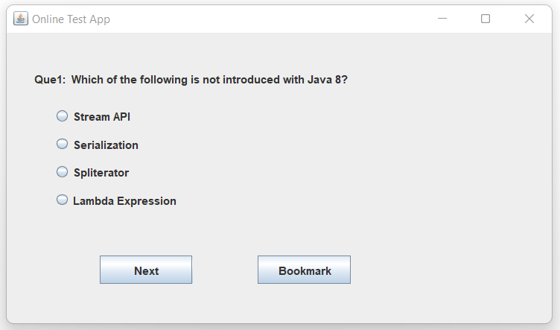

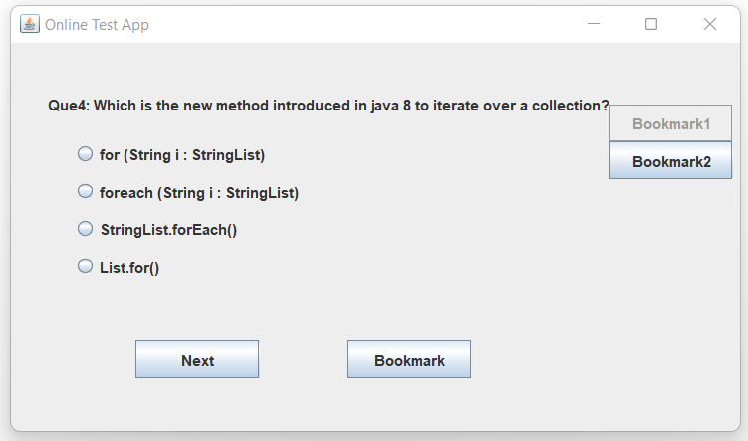

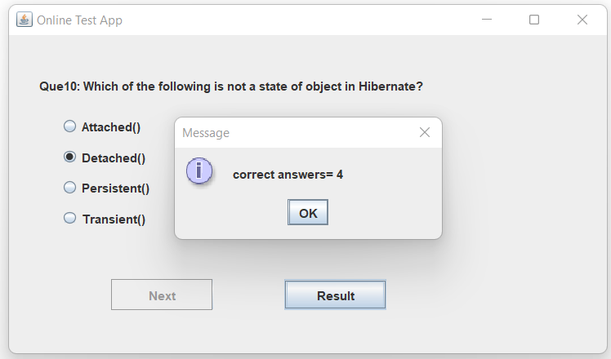

**Conclusion :-**

Online Examination java project allows faculties to create their own tests. It would enable educational institutes to perform tests, quiz and create feedback forms. It asks faculty to create his/her set of questions. Faculty then creates groups and adds related students into the groups. Further the tests are associated with specific groups so that only associated students can appear for the test.

**______________________________________________________________**